This is the first post of a series on the concept of “network centrality” with  
applications in R and the package netrankr. The main focus of the  
blog series will be the applications in R and conceptual considerations will only play a minor role.

library(igraph)

library(ggraph)

library(tidyverse)

library(netrankr)

**Introduction**

Research involving networks has found its place in a lot of disciplines. From  
the social sciences to the natural sciences, the buzz-phrase “networks are everywhere”, is everywhere.  
One of the many tools to analyze networks are measures of *centrality*.  
In a nutshell, a measure of centrality is an index that assigns a numeric values to  
the nodes of the network. The higher the value, the more central the node (A more thorough introduction is given in the extended tutorial).

If you work, or intend to work, with centrality and haven’t read it, I urge you to do so.  
Freeman does not mince matters and goes all-in on criticizing contemporary work of that time.  
He calls existing indices “nearly impossible to interpret”, “hideously complex”, “seriously flawed”, “unacceptable”, and “arbitrary and uninterpretable”. His rant culminates in the following statement.

The several measures are often only vaguely related to the intuitive ideas they purport to index,  
and many are so complex that it is difficult or impossible to discover what,  
if anything, they are measuring.

and he concludes:

There is certainly no unanimity on exactly what centrality is or on its conceptual foundations,  
and there is very little agreement in the proper procedure for its measurement.

So, up to the 1970s, many different centrality indices have already been proposed, which assessed different  
structural features of networks in order to determine central nodes. But Freeman found this  
measures hardly appropriate and criticized their overabundance. He argued that the vast array of indices can be  
boiled down to three indices: degree, betweenness and closeness. Everything else was just an awkward  
variant of one of these measures. Note though, the indices already existed and were not designed  
by him. How was this work received?  
As of November 2019, the paper has been cited over 14000 times. It is by far the most  
the most influential work in the area of centrality. But did it change how we handle  
centrality today? The list of existing centrality indices is huge and new centrality indices are  
still crafted on a regular basis. Thus, it seems that Freeman’s “no unanimity” statement is still  
relevant today. The ambiguities surrounding centrality poses many challenges for empirical work.  
Some of the reoccurring questions are:

* Which index do I choose for my analysis?
* Should I maybe design a new one?
* How do I validate that the chosen index is appropriate?

While the answer to the second question is easy (**Don’t do it!**), the others are a bit more tricky.

In this post, I will review existing R Package that are relevant for centrality related analyses  
and illustrate why considering the above mentioned questions is necessary.

**R packages for centrality**

(*This section lists a great variety of different indices. If you are interested in the technical details,  
consult the help of the function and check out the references*)

There are several packages that implement centrality indices for R.  
Of course, there are the big network and graph packages such as  
igraph,sna, qgraph, and tidygraph, which are designed as general purpose packages  
for network analysis. Hence, they also implement some centrality indices.

igraph contains the following 10 indices:

* degree (degree())
* weighted degree (graph.strength())
* betweenness (betweenness())
* closeness (closeness())
* eigenvector (eigen_centrality())
* alpha centrality (alpha_centrality())
* power centrality (power_centrality())
* PageRank (page_rank())
* eccentricity (eccentricity())
* hubs and authorities (authority_score() and hub_score())
* subgraph centrality (subgraph_centrality())

In most cases, parameters can be adjusted to account for directed/undirected and  
weighted/unweighted networks.

The sna package implements roughly the same indices together with:

* flow betweenness (flowbet())
* load centrality (loadcent())
* Gil-Schmidt Power Index (gilschmidt())
* information centrality (infocent())
* stress centrality (stresscent())

qgraph specializes on weighted networks. It has a generic function centrality_auto()  
which returns, depending on the network, the following indices:

* degree
* strength (weighted degree)
* betweenness
* closeness

The package also contains the function centrality(), which calculates a non-linear combination  
of unweighted and weighted indices using a tuning parameter \(\alpha\) (See [Opsahl et al.](https://www.sciencedirect.com/science/article/pii/S0378873310000183)).

There are also some dedicated centrality packages, such as centiserve, CINNA, influenceR and keyplayer.  
The biggest in terms of implemented indices is currently centiserve with a total of 33 indices.

as.character(lsf.str("package:centiserve"))

## [1] "averagedis" "barycenter"

## [3] "bottleneck" "centroid"

## [5] "closeness.currentflow" "closeness.freeman"

## [7] "closeness.latora" "closeness.residual"

## [9] "closeness.vitality" "clusterrank"

## [11] "communibet" "communitycent"

## [13] "crossclique" "decay"

## [15] "diffusion.degree" "dmnc"

## [17] "entropy" "epc"

## [19] "geokpath" "hubbell"

## [21] "katzcent" "laplacian"

## [23] "leaderrank" "leverage"

## [25] "lincent" "lobby"

## [27] "markovcent" "mnc"

## [29] "pairwisedis" "radiality"

## [31] "salsa" "semilocal"

## [33] "topocoefficient"

The package is maintained by the team behind centiserver,  
the “comprehensive centrality resource and server for centralities calculation”.  
The website collects indices found in the literature. Currently (December 2018), it lists 235 different indices.  
That’s…a lot.

CINNA is a relatively new package (first CRAN submission in 2017). The package description says  
“Functions for computing, comparing and demonstrating top informative centrality measures within a network.”  
Most of the indices in the package are imported from other package, such as centiserve.  
In addition, there are:

* Dangalchev closeness (dangalchev_closeness_centrality())
* group centrality (group_centrality())
* harmonic closeness (harmonic_centrality())
* local bridging centrality (local_bridging_centrality())

The function calculate_centralities() can be used to calculate all applicable indices  
to a network. The primary purpose of the package is to facilitate the choice of indices  
by visual and statistical tools.

influenceR and keyplayer are comparably small packages which implement only a small  
number of indices.

*(For now, I deliberately leave out my package netrankr. While it implements a great variety of indices,  
it is not its primary purpose to provide a set of predefined measures. We will come to that in  
the next part.)*

You really have the agony of choice if you look at this exhaustive list of possibilities.

**A small example**

Let us start with a fairly simple example. Consider the following two small networks.

#data can be found here: https://github.com/schochastics/centrality_tutorial

g1 <- readRDS("example_1.rds")

g2 <- readRDS("example_2.rds")

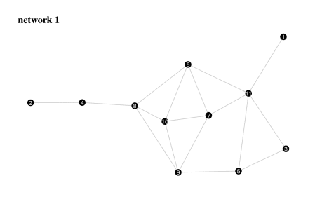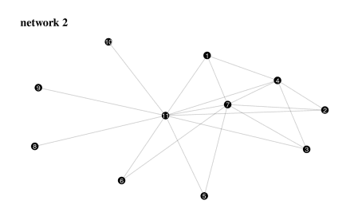

Now, without any empirical context, we want to determine the most central node in both networks.  
I wrote a small function (code at the end of this post), which calculates 35 of the above mentioned  
indices. We blindly apply them to both networks and see what happens.

res1 <- all_indices(g1)

res2 <- all_indices(g2)

The chart below shows a breakdown for how many indices return a specific node as the most central one.

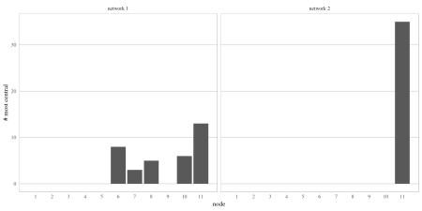

In network 1, five different nodes are considered to be “the most central node” by different  
indices. In network 2, on the other hand, all 35 indices agree on node eleven as the most  
central one. The take away message from network 1 is clearly that choice matters.  
Depending on which index we choose, we can obtain very different results. This is hardly  
surprising. Why else would there be so many different indices? Five different centers are, however,  
a lot for such a tiny network. Network 2 paints a completely different picture.  
All indices agree upon the most central node. Even better (or worse?), they all  
induce the same ranking. We can check that with the function compare_ranks() in  
netrankr by counting the wrongly ordered (discordant) pairs of nodes for pairs of indices \(x\) and \(y\).  
That is, \(x\) ranks a node \(i\) before \(j\) but \(y\) ranks \(j\) before \(i\).

(*The function is unfortunately not properly vectorised yet, so we need to resort to some for looping*)

discordant <- rep(1,35*34)

k <- 0

for(i in 1:(ncol(res2)-1)){

for(j in (i=1):ncol(res2)){

k <- k+1

discordant[k] <- compare_ranks(res2[,i],res2[,j])$discordant

}

}

any(discordant>0)

## [1] FALSE

So, the indices not only agree upon the most central node, but also on the rest of the ranking!

You may be wondering, why we are only looking at the ranking and not the actual values.  
Effectively, the values themselves don’t have any meaning. There is no such thing as  
a “unit of centrality”, if we look at it from a measurement perspective. For instance, we can’t say that  
a node is “twice as between” as another if its betweenness value is twice as high. Centrality  
should thus not be considered to be on an interval scale, but rather an ordinal one.  
This might seem like a restriction at first, but we will see later on that it facilitates  
many theoretical examinations.

The two networks illustrate the big problem of choice. We have “only” tried 35 different  
indices, so we actually can’t make any conclusive statements about central nodes.  
After all, 35 indices can in the best case produce 35 completely different rankings.  
But theoretically, there are \(11! =\) 39,916,800 possibilities  
to rank the nodes of the network without allowing ties, which indices actually do.  
So, what if we missed hundreds of thousands of potential indices that would rank, say,  
node nine on top for network 1? What if those 35 indices are exactly the ones  
that rank node eleven on top for network 2, but no other index does that?

In the next example, we add some (made up) empirical context to illustrate the  
problem of how to validate the appropriateness of chosen indices.

**An almost realistic example**

Centrality indices are commonly used as an explanatory variable for some observed  
phenomenon or node attribute in a network. Let’s say we have the following abstract research question.  
Given a network where each node is equipped with a binary attribute, which could  
signify the presence or absence of some property. Can a centrality index “explain” the presence  
of this attribute?

#data can be found here: https://github.com/schochastics/centrality_tutorial

g3 <- readRDS("example_3.rds")

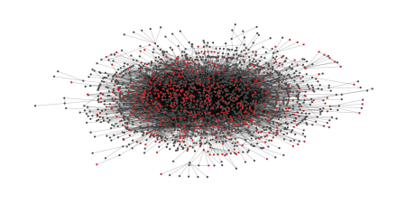

Instead of 35 indices, we here focus on the more common indices.

cent <- tibble(nodes=1:vcount(g3),attr=V(g3)$attr)

cent$degree <- igraph::degree(g3)

cent$betweenness <- igraph::betweenness(g3)

cent$closeness <- igraph::closeness(g3)

cent$eigen <- igraph::eigen_centrality(g3)$vector

cent$subgraph <- igraph::subgraph_centrality(g3)

cent$infocent <- sna::infocent(get.adjacency(g3,sparse=F))

glimpse(cent)

## Observations: 2,224

## Variables: 8

## $ nodes 1, 2, 3, 4, 5, 6, 7, 8, 9, 10, 11, 12, 13, 14, 15,...

## $ attr 0, 0, 0, 0, 1, 0, 1, 0, 0, 0, 0, 0, 0, 0, 0, 0, 0,...

## $ degree 1, 1, 1, 3, 1, 5, 3, 2, 10, 5, 3, 3, 1, 11, 15, 5,...

## $ betweenness 0.0000, 0.0000, 0.0000, 112.0519, 0.0000, 3181.837...

## $ closeness 9.448224e-05, 9.559316e-05, 7.303535e-05, 1.089562...

## $ eigen 9.356028e-03, 6.160046e-03, 5.509022e-05, 1.107902...

## $ subgraph 830.570056, 364.526673, 1.632701, 2814.242127, 1.8...

## $ infocent 0.5634474, 0.5843892, 0.3409455, 1.0096304, 0.4697...

If we postulate that one of the indices is somehow related with the attribute, then  
we should see that nodes with the attribute should tend to be ranked on top of the induced ranking.  
The below bar chart shows the number of nodes having the attribute that are ranked in  
the top 150 for each index.

cent %>%

gather(cent,value,degree:infocent) %>%

group_by(cent) %>%

top_n(150,value) %>%

dplyr::summarise(top=sum(attr)) %>%

ggplot(aes(reorder(cent,top),y=top))+

geom_col()+

ggthemes::theme_tufte(ticks = F)+

theme(panel.background = element_rect(fill=NA,colour="grey"),

panel.grid.major.y = element_line(colour = "grey"))+

labs(y="attr in top 150",x="")

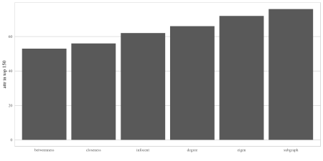

According to this crude evaluation, subgraph centrality is best in “explaining”  
the node attribute. But how conclusive is this now? Note that we did not specify any  
real hypothesis so basically any index could be a valid choice. Instead of  
trying out one of the other mentioned ones though, we now try to design a new index  
which hopefully gives us an even better “fit”. After some wild math, we may end up with something like this:

\[  
c(u)= ccoef(u) \left[\sum\limits_{v \in N(u)} \sum\limits_{k=0}^{\infty} \frac{(A^{[u]})_{vv}^{2k}}{(2k)!} \right]  
\]  
Ok, so what is happening here? \(ccoef(u)\) is the clustering coefficient of the node \(u\) (igraph::transitivity(g,type="local")). The first sum is over all neighbors \(v\) of \(u\). The second sum is used to sum up all closed walks of even length weighted by the inverse factorial of the length.

We can directly invent a second one, based on the walks of odd length.  
\[  
c(u)= ccoef(u) \left[\sum\limits_{v \in N(u)} \sum\limits_{k=0}^{\infty} \frac{(A^{[u]})_{vv}^{2k+1}}{(2k+1)!} \right]  
\]  
Mathematically fascinating, yet both indices defy any rational meaning.

Both indices have not yet been considered in the literature (please do not write a paper about them!).  
However, they are not entirely new.  
The indices are implemented in netrankr as the *hyperbolic index*.

cent$hyp_eve <- hyperbolic_index(g3,type = "even")

cent$hyp_odd <- hyperbolic_index(g3,type = "odd")

How do they compare to the other indices?

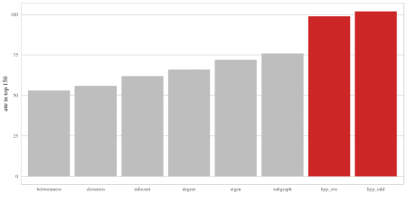

Both indices are far superior. Around 66% of the top 150 nodes are equipped  
with the attribute, compared to 50% for subgraph centrality.

A better evaluation may be to treat the problem as a binary classification problem  
and calculate the area under the ROC curve as a performance estimate.

cent %>%

gather(cent,value,degree:hyp_odd) %>%

select(-c(nodes)) %>%

group_by(cent) %>%

yardstick::roc_auc(factor(attr),value) %>%

arrange(-`.estimate`) %>%

knitr::kable()

| **cent** | **.metric** | **.estimator** | **.estimate** |
| --- | --- | --- | --- |
| hyp_odd | roc_auc | binary | 0.6944020 |
| hyp_eve | roc_auc | binary | 0.6925552 |
| degree | roc_auc | binary | 0.6571969 |
| infocent | roc_auc | binary | 0.6510916 |
| subgraph | roc_auc | binary | 0.6407756 |
| eigen | roc_auc | binary | 0.6316241 |
| closeness | roc_auc | binary | 0.6137547 |
| betweenness | roc_auc | binary | 0.6046209 |

Again, the hyperbolic indices overall perform much better than the other traditional indices.

Obviously, this is a very contrived example, yet it emphasizes some important points.  
First, it is relatively easy to design an index that gives you the results you intend to get and hence  
justify the importance of the index. Second, you can never be sure, though, that you found “the best” index for the task. There may well be some even more obscure index that gives you better results. Third, if you do not find a fitting index, you can not be sure that there does not exist one after all.

**Summary**

This post was intended to highlight some of the problems that you may encounter when  
using centrality indices and how hard it is to navigate the index landscape, keeping up with all  
the newly designed ones.

One is therefore all to often tempted to go down the data-minning road.  
That is, take a handfull of indices, check what works best and come up with a post-hoc  
explanation as to why the choice was reasonable. Note, though, that this approach is not  
universally bad, or wrong. It mainly depends on what you your intentions are.  
You simply want to have a sort of predictive model? Go wild on the indices and maximize!  
The CINNA package offers some excellent tools for that.

However, if you are working in a theory-heavy area, then this approach is not for you.  
“Trial-and-Error” approaches are hardly appropriate to test a (causal) theory.  
But how can we properly test a hypothesis with measures of centrality, when obviously

there is very little agreement in the proper procedure for its measurement.

The upcoming posts will discuss a different approach to centrality, which may help  
in translating a theoretical construct into a measure of centrality.

**Additional R Code**

all_indices <- function(g){

res <- matrix(0,vcount(g),35)

res[,1] <- igraph::degree(g)

res[,2] <- igraph::betweenness(g)

res[,3] <- igraph::closeness(g)

res[,4] <- igraph::eigen_centrality(g)$vector

res[,5] <- 1/igraph::eccentricity(g)

res[,6] <- igraph::subgraph_centrality(g)

A <- get.adjacency(g,sparse=F)

res[,7] <- sna::flowbet(A)

res[,8] <- sna::loadcent(A)

res[,9] <- sna::gilschmidt(A)

res[,10] <- sna::infocent(A)

res[,11] <- sna::stresscent(A)

res[,12] <- 1/centiserve::averagedis(g)

res[,13] <- centiserve::barycenter(g)

res[,14] <- centiserve::closeness.currentflow(g)

res[,15] <- centiserve::closeness.latora(g)

res[,16] <- centiserve::closeness.residual(g)

res[,17] <- centiserve::communibet(g)

res[,18] <- centiserve::crossclique(g)

res[,19] <- centiserve::decay(g)

res[,20] <- centiserve::diffusion.degree(g)

res[,21] <- 1/centiserve::entropy(g)

res[,22] <- centiserve::geokpath(g)

res[,23] <- centiserve::katzcent(g)

res[,24] <- centiserve::laplacian(g)

res[,25] <- centiserve::leverage(g)

res[,26] <- centiserve::lincent(g)

res[,27] <- centiserve::lobby(g)

res[,28] <- centiserve::markovcent(g)

res[,29] <- centiserve::mnc(g)

res[,30] <- centiserve::radiality(g)

res[,31] <- centiserve::semilocal(g)

res[,32] <- 1/centiserve::topocoefficient(g)

res[,33] <- CINNA::dangalchev_closeness_centrality(g)

res[,34] <- CINNA::harmonic_centrality(g)

res[,35] <- 1/CINNA::local_bridging_centrality(g)

apply(res,2,function(x) round(x,8))

}